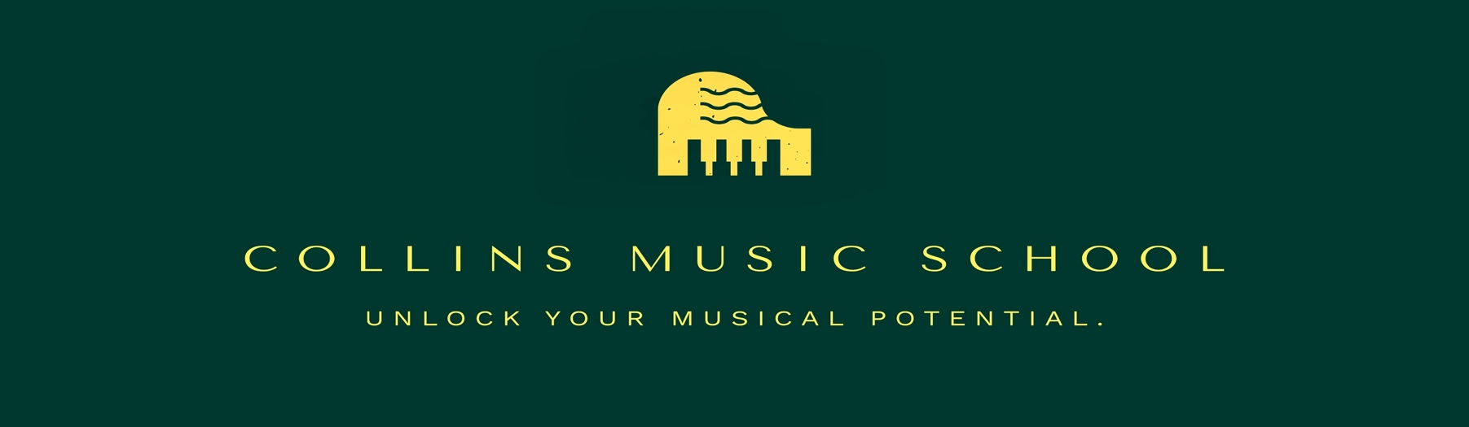
Photo/Video release form
I hereby grant consent for the usage of images showing myself, obtained during piano lessons at Collins music school, through the means of video, photography, and digital cameras, exclusively for the purpose of promoting Collins music school and its publications. Furthermore, I waive any entitlement to compensation or ownership of said images.
Name of Participant: ____________________________________ Age:____________
Signature: ____________________________________________ Date:____________

